**Student’s Name: ………………………………………**

|  |  |
| --- | --- |
| **Class** | **Stream** |
| **S. 2** |  |

**545/1**

**CHEMISTRY**

(Theory) **Paper 1**

APIRL 2023

2 hours

# Uganda Certificate Of Education

**S.2 COMPETENCE BASED ASSESSMENT EXAMINATIONS**

**INSTRUCTIONS:**

* *Answer* ***all*** *questions in the Answer sheets provided.*
* *Illustrations in form of drawings should be made where necessary, with a sharp pencil.*

1. (a) The figure below shows some examples of important chemical reactions in our daily life.

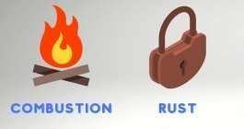

* + 1. Briefly explain the meaning of the chemical reactions shown above (04 marks)

Combustion

Rust

* + 1. State one condition of each process to occur (02 marks)

Combustion

Rust

* + 1. How can you prevent your metallic equipments from rusting (04 marks)

1. As a senior two chemistry student, make a write up giving meanings and examples of the bolded words in the boxes. (10 marks)

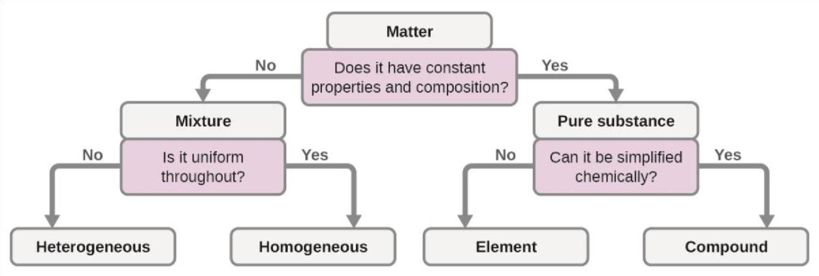

1. The figure below shows the heating and cooling curves for substances X and Y. Study it and answer the questions that follow



1. What was the original state of substance X and Y? **(02 marks)**

**(b)** Explain the changes of state throughout for X and for Y (08 MARKS)

4(a).Kinetic theory of matter states that “*matter consists of very smallest invisible particles in the state of continuous random motion"* A teacher instructed S.2 students to come up with every day examples demonstrating the existence of particles in matter.

Owen; a S.2 student presented his example before the whole class. His presentation was “ ***when some one closes him or herself in a dark room with closed windows and doors and looks into a ray of light penetrating through one simple hole in one piece of iron sheet, dust particles are seen moving in a zig zag pattern “*** the teacher confirmed Owen's findings.

(i) State why the dust particles are seen moving in zig zag pattern.?

(01 mark)

(ii) Give a reason for your answer in (a) (01mark)

(iii) What conclusion can be drawn from Owen's simple experiment?

(01 mark)

(iv) State what would be observed within the ray of light when the room gets hotter? (01 mark)

(v) Explain your observations in (c) above. (02 mark)

5. From the support material below.a

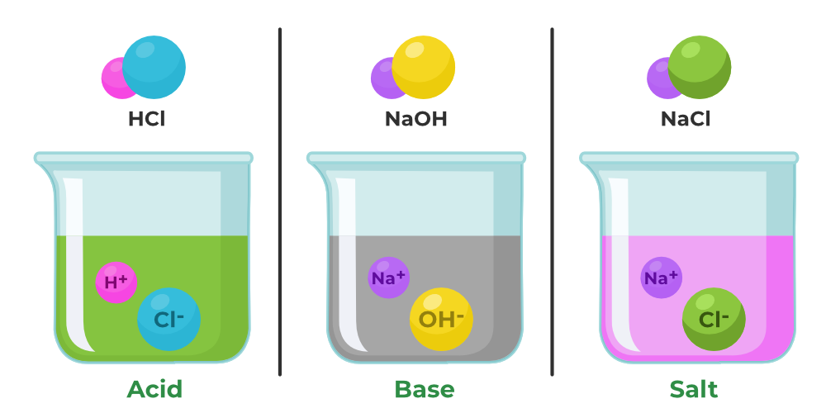

Answer the questions below

(a)Using the support material above, write a speech to your fellow students to make them understand the substances above. (10 marks)

(b)Write down the symbols of the following elements (04 marks)

|  |  |  |  |  |  |  |
| --- | --- | --- | --- | --- | --- | --- |
| Element | Bromine | Silver | Potassium | Nitrogen | Aluminium | Silcon |
| Symbol |  |  |  |  |  |  |

END